**“Impacts of Intelligent Automation**

**(AI And RPA)”**

**A SEMINAR REPORT**

*Submitted by*

**Mr. Ritik Vinod Nandanwar**

***in partial fulfillment for the award of the Third Yr. B. Tech seminar***

***of***

**Third Year B. Tech (CSE)**

**IN**

**Computer Science and Engineering**

**At**



**SHRI GURU GOBIND SINGHJI**

**INSTITUTE OF ENGINEERING AND TECHNOLOGY,**

**VISHNUPURI, NANDED**

**(MAHARASHTRA STATE)**

**PIN 431 606 INDIA**

**Oct 2020**

TABLE OF CONTENTS

CHAPTER NO.                                            TITLE                                          PAGE NO.

ACKNOWLEDGMENT                i

ABSTRACT                         ii

**1.                INTRODUCTION                    1-6**

1.1 Introduction                        1

1.2 Machine Learning                    3

1.3 Artificial Intelligence                4

1.3 Robotic Process

Automation         5

1.4 Business and Innovation                   6

**2.                 LITERATURE SERVEY                7-11**

2.1 Overview of survey

papers           7

2.2 Conclusion                   9

2.3 References 10

**3. APPENDIX 11-13**

2.4 Appendix A 12

**ACKNOWLEDGEMENT**

First and foremost, I would like to thanks to my parents for there initiative and blessings throughout my work in order to complete a case study well.

Secondly, I would like to express my special thanks of gratitude to my teacher **Mr. Sumit Wattamwar** assistant professor (CSE) ,Shri Guru Gobind Singhji Institute of Engineering And Technology, Nanded, who gave me the golden opportunity and providing invaluable guidance to do this wonderful case study of Technical Seminar on “IMPACTS OF INTELLIGENT AUTOMATION(AI and RPA)”, Who also helped me in completing my case study .He had taught me the methodology to carry out the case study and to present the research works as clearly as possible. I came to know about so many new things regards the automation, I am really thankful to him. And again, I would also like to thank my parents and friends who helped me a lot in finalizing this case study within the limited time frame

I would also appreciate the researches, blog, statements and documentation which are being helpful to do this case study. They are very useful through this journey.

**Ritik Vinod Nandanwar**

**(2018bcs111)**

i

**ABSTRACT**

Robot intelligence works with humans to amplify our intelligence. .Modern information technologies and the arrival of machine powered by artificial intelligence have already strongly affected the world of work in the 21st century Computers ,algorithm and software everyday tasks and it is impossible to imagine how most process steps could be managed without human force .This automation is impacting the business models .This report is an summary of the above mentioned titles .Here we discuss how world is changing day by day ? Is this intelligent automation being a future of humanity? or is resulting the workers to lose their jobs? Are we ready for this to get the answer to our mentioned question I have come with some information based on the recent data provided with the pictorial data? And based on this information we are going to make a conclusion.

First, AI enables an organization to overcome many past limitations of human‐intensive design processes, by improving the scalability of the process, broadening its scope across traditional boundaries, and enhancing its ability to learn and adapt on the fly. Second, and maybe more surprising, while removing these limitations, AI also appears to deeply enact several popular design *principles*. AI thus reinforces the principles of Design Thinking, namely: being people‐centered, abductive, and iterative. In fact, AI enables the creation of solutions that are more highly user centered than human‐based approaches (i.e., to an extreme level of granularity, designed for every single person); that are potentially more creative; and that are continuously updated through learning iterations across the entire product life cycle.

***Keywords: - Machine learning, Artificial Intelligence, Robotic Process Automation, Business and Innovation***

ii

* 1. **Introduction**

We are the humans the most brilliant animal on the planet. The rise of the machine era was beginning when we create the computers. From then to now and onwards the machine is going to be the part of daily routine. Every day we use at least one machine. Here we are going to discuss about the technical success in area of machine is Automation or we say Intelligent Automation. What is intelligent automation?

Intelligent automation incorporates recent advances in technology to manage and improve business processes automatically and continuously. Constituent components of intelligent automation include:

• AI/machine learning – The application of systems equipped with software that simulates human intelligence processes, including learning without explicit instructions.

• Natural language processing – The ability to understand human speech as it is spoken.

• Robotics – The use of robots that can act on Internet of Things (IoT) and other data to learn and make autonomous decisions.

• Predictive analytics – The practice of predicting outcomes using statistical algorithms and machine learning.

The first AI was created by the first autonomous robots in the history of automation were created in 1948 by William Grey Walter. These came in the shape of two ‘tortoises’: Elmer and Elsie. The 1990s was a time for major advances in AI. An artificial intelligence called ‘Deep Blue’ defeated chess grandmaster Garry Kasparov at chess (1997). NASA deployed its first autonomous robotics system, Sojourner, on the surface of Mars.

Here some graphs related with the intelligent automation.

The number of published academic papers featuring AI has risen dramatically. 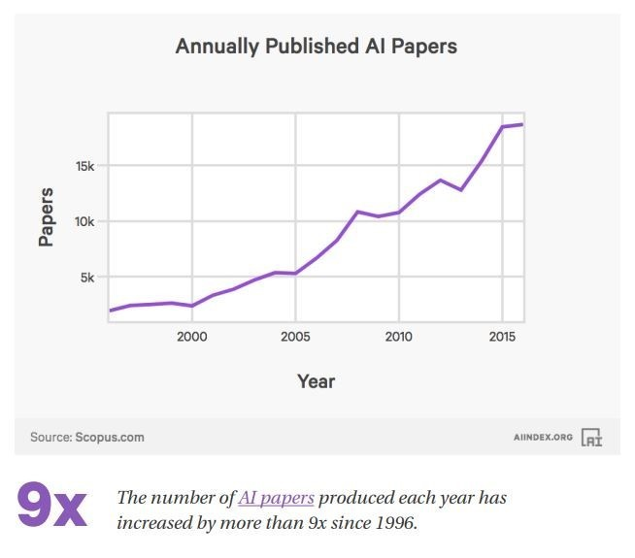

***Figure:1*** 1

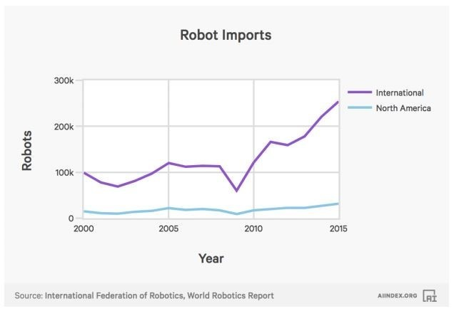

***Figure :2***

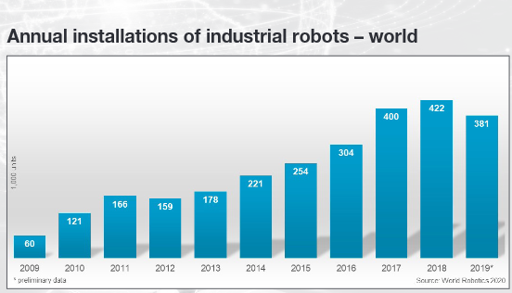

***Figure:3***

2

**1.2 Machine learning (ML)**

Machine learning is an application of artificial intelligence (Al) that provides systems the ability to automatically learn and improves from experience without being explicitly programmed. Machine learning focuses on the development of computer programs that can access the data and use it learn for themselves. By means of generating the logic in between the attributes of the given data. Machine learning is undoubtfully one of the most influential and powerful technologies in today’s world. Machine learning focuses on the development of computer programs that can access the data and use it learn for themselves.

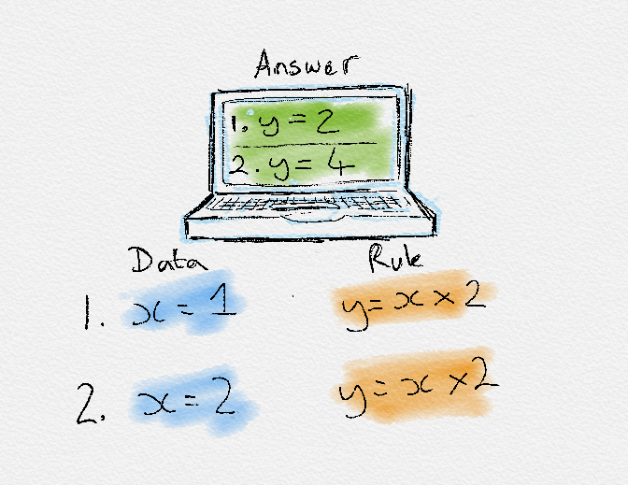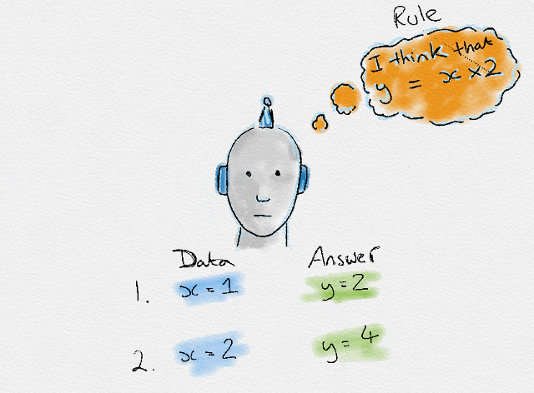

In our everyday life we deal with machine learning, every time we search on a google, listen to a song, Machine learning is becoming part of engine behind it. Software engineering combined human created with data to create answers to a problem. Instead, machine learning uses data and answers to discover the rules behind a problem. Resurging interest in machine learning is due to the same factors that have made data mining and Bayesian analysis more popular than ever. Things like growing volumes and variables and varieties of available data, computational processing that is cheaper and more powerful, and affordable data storage. Most industries working with large amount of data have recognized the value of machine learning technology. By gleaning insights from this data – often in real time – organizations are able to work more efficiently or gain an advantage over competition. Here are the some of the most adopted machine learning methods are supervised learning and unsupervised learning – but there are also other methods of machine learning. Here’s an overview of the most popular types.

* Supervise Learning
* Reinforcement Learning
* Semi-supervised Learning
* Inductive Learning
* Deductive Learning.

3

**1.3 Artificial Intelligence (AI)**

Artificial intelligence (AI) is a wide-ranging branch of computer science concerned with building smart machines capable of performing tasks that typically require human intelligence .AI is an interdisciplinary science with multiple approaches, but advancements in machine learning and deep learning are creating a paradigm shift in virtual every sector of the tech industry. In a textbook named “*Artificial Intelligence: A Modern Approach”*, author Stuart Russell and Peter Norvig give introduce this term of AI “the study of agents that receive percept from the environment and perform actions”.

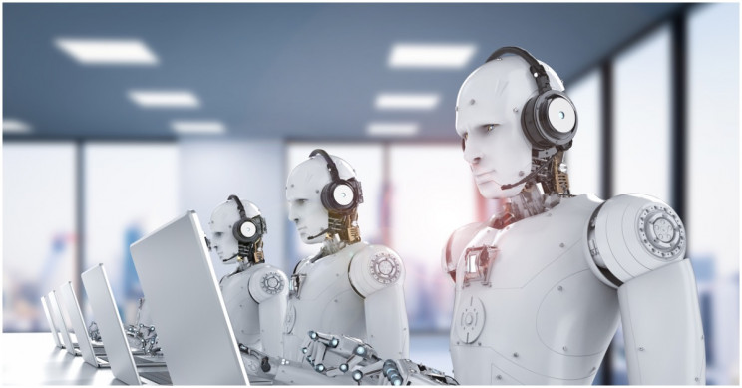

Andrew Ng, co-founder Google Brain; former vice president & chief scientist of Baidu; co-chairman and co-founder of Coursera and an adjunct professor at Stanford University said in 2017 at Stanford MSx (Master of Science in Management for Experienced Leaders) Program (Lynch 2017)-“Just as electricity transformed almost everything 100 years ago, today I actually have a hard time thinking of an industry that I don’t think AI will transform in the next several years”. The AI’s major practical application: processing the vast amounts of data generated daily. AI's ability to work so well with data analytics is the primary reason why AI and Big Data are now seemingly inseparable. AI machine learning and deep learning are learning from every data input and using those inputs to generate new rules for future business analytics. ... “Data is the lifeblood of AI. IBM posted a post in march 2012 and “mentioned there 90% data of world is generated in last two years”, As the data is lifeblood of the AI, we can see that how the AI becoming the trend in the world .

4

**1.4 Robotic Process Automation (RPA)**

Robotic Process Automation (RPA) is software technology that’s easy for anyone to use to automate digital tasks. With RPA, software users create software robots, or “bots”, that can learn, mimic, and then execute rules-based business processes. RPA automation enables users to create bots by observing human digital actions. Show your bots what to do, then let them do the work. Robotic Process Automation software bots can interact with any application or system the same way people do—except that RPA bots can operate around the clock, nonstop, much faster and with 100% reliability and precision.

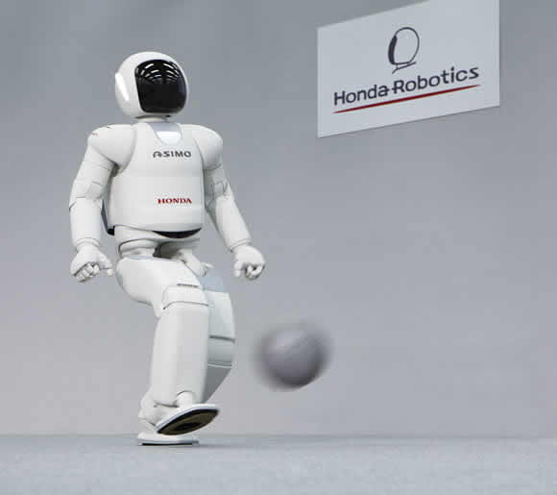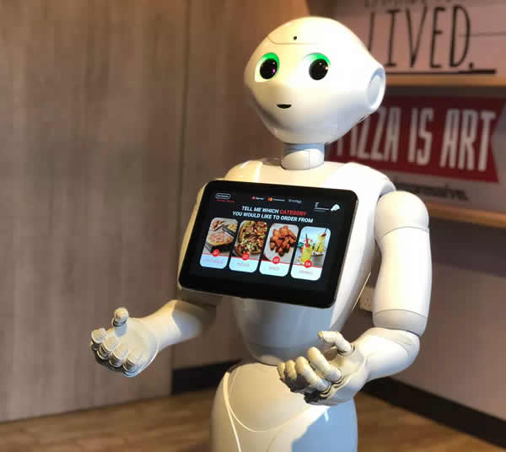

As we see the two images above on left side we have ASIMO is a humanoid robot created by Honda in 2000 and it is updated time to time tomake it most advanced social robot and on right we have Pepper it is the first robot that is capable of recognization of human emotions. Pepper is social, capable of having conversations with people, giving them direction and even dancing with them .This are examples of combined RPA and AI, there are also more examples of RPA. RPA is for convienience for human, to make our work easy and it is technology which is helping us to move farwards fastly.In , future everyone will be holding its own robot or say replica of himself/herslef in the form of Intelligent Automation.

5

**1.5 Business and Innovation**

Automation is already having the significant impact on how business handle orders, complete projects and serve users. From machine learning to creating software robots that perform the kinds of repetitive tasks that most humans avoid. Automation streamlines your process without sacrificing accuracy or quality. When your team can access the accurate data, they need to perform their jobs, efficiency naturally goes up. Without automation your employees need to accurately input information, complete tasks and then remember to alert other workers to move the project along or complete essential duties. Once you automate the critical tasks, they can be completed smoothly and then the proper teams or groups can be notified .At its best ,automation does not replace human workers, it enhanced their roles and made their jobs easier and more efficient. Automation is not a one-size-fits-all solution; we can pick and choose how we integrate the latest innovations in automation, so they most benefit your business and workflow. Careful consideration of which tasks in your different procedures and methods are the best candidates for automation can help you make the most of the technology.

The states of AI and RPA in Business

* Only 23% of Business have incorporated AI into process and product/services offering today.
* The largest companies (Those with at least 100,000 employees) are the most likely to have an AI strategy, but only half have one.
* 47% of digitally mature organizations say they have a defined AI strategy.
* RPA, as an enterprise in growing exponentially researches, predicts that RPA will raise from $250 million in 2016 to $2.9 billion in 2021.
* According to Deloitte’s third annual RPA survey, a wealth of data upon RPA, 53% of study respondents are starting their study.
* Deloitte thinks that in the trend remains, RPA will reach “near universal adoption” in the subsequent three years
* Among these surveyed, RPA suffices and surpasses expectations within terms of quality, compliance, productivity, accuracy, also cost reduction.

6

**2.1 Overview of Survey Paper**

In research paper mentioned below, researcher provides the appropriate answer of questions which were the base of provided research <https://arxiv.org/ftp/arxiv/papers/1905/1905.02092.pdf> done by Neha Soni, Enakshi Khular Sharma, Narotam Singh, Amita Kapoor. In its researcher included the term of Fourth Industrial Revolution or Industry 4.0 (Schwab 2017; Bloem 2014; Klosters 2016; Park 2017). Before getting jump into the paper let take short brief on this term. The fundamental changes in our daily work routine, the way we live and interact with others, is all going to be represented by the fourth industrial revolution Moving from the third to the fourth industrial revolution is going to open a new chapter in human development – incorporating the extraordinary technological advances. Economists say the fourth industrial revolution has a significant tendency to improve the lifestyle of the people all across the globe by raising global income levels. For now, consumers are the ones who are taking the most advantage from the digital world because of AI-powered products and services. The fourth industrial revolution mainly represents a confluence of different technologies – artificial intelligence, machine learning, augmented, and virtual reality. Internet of things into innovative products, services, and industries. Also, paper introduce to a various real application which are currently being used world. Providing the history of AI how it is come from setbacks like the reduced funding’s called AI winters. with following of the enlighten of the AI how it come back and playing the major role in our life today. By the help of certain measures, the researcher was trying to show us from how the AI changed the people interested towards it. Next to it they come with topic named Reshaping the Innovation process, which is telling us, how this new path of technology changes the environment in processes. Considering the Data as fuel for the automation. In few years due to lower prices of the sensors and low power sensors resulting the generation the data. Which will then result into the data required for the AI models in order to analyze the problems and provide the result. This result is due to some of AI or Machine learning tools like Bayesian algorithms, support vector machines (SVM), decision trees, deep learning networks (DLN) and ensemble configurations. Preceding paper they provide the information about the how the tech Giants (Google, Apple, IBM, Amazon, Microsoft) are come with AI startup Acquisitions on the basis of the Financial analysis they had done. This study is done with the help of data implementing using the Mosaic algorithm. And this all startups require the large amount of the investments providing the statistics how the investments are done in this all startups. This adoption of AI technology in the organization has also to led to the shaping of business contexts. They also talk about the human skills required for replacing the AI bots. By the end of report, they also predict the situation of upcoming years due to AI what actually people are going to do and how to do.

Moving on to the next research paper that we are going to assume is the “The strategic impacts of Intelligent Automation for knowledge and service work: An interdisciplinary review”, Introduced by the Crisspin Coombs, Donald Hislop, Stanimira K.Taneva, Sarah Bernard. The paper title itself describe what is in it, though there is a lot of interesting thing that I am going to describe it. Let`s take the overlook the paper, in introduction they had started with the provided information on the basis of forecasts done by analysts leading to the evidences of that how unemployment due to automation was occurred in recent year.

7

Analyst also predicts that in upcoming ten years Artificial Intelligence outperform the human in many activities becoming the alternative for human. Follow on they come with their concept of the intelligent automation. Giving the plenty of the term which are mentioned by some of the author in respective speeches. Introducing the technology required for the Artificial intelligence which help the reader to make it clear how the tools had been used or using. Displaying the table which consists of three columns namely Application, Description and Limitations. This research paper was is the summarization of some research that had been before ad some important statements of the researcher and technicians. Here they come with the table1 (In appendix A) giving the answer of some question which might be an usual thought while reading paper. Next to it describing the questions and its answer which are mentioned in the table1 (In AppendixA). These questions are the base of the mentioned research paper. Thus, this massive research paper it actually was the brief knowledge regards the Intelligent Automation and is effects on the Knowledge and service works.

8

**2.2 Conclusion**

To understand the size and nature of the literature regrading the impacts of the Intelligent automation (AI and RPA) , I undertook a scoping review on the research paper, I mentioned in the above chapter and taking help of the some statements, blogs and documentation which are mentioned in the references at the end of the this case study. This case study regards the title mentioned above is for analyzing and studying the will and woe of the Intelligent Automation. As, I go through the sum of researches regards the topic and I had introduced myself with some new terms in the field of the Intelligent Automation. As we all know Automation is now the leading need of the industry, every company/startup wants themeselve in the list of AI based company/startups. In this era of technology, we are generating the data every year more than its last year. This leads to the AI empowerment. Based on the comprehensive multi-disciplinary literature review and some of analysis I make a conclusion, That AI has its own benefit to the humans like, Everywhere we see applications of it, before AI we are enable of predicting something more precisely but now with the help of the machine learning we can predict the everything which is related to the data, In industry where sometimes misfortunes occur with workers but now with Robotic Process Automation we are reducing the chance of such misfortunes. In introduction there are some statistics showing how people are actually reacting related to the Automation. Investments in the sector of the AI are increased, use of robots is increased year by year exception 2020 due to pandemic there is lack of selling robots but that is negligible. We can see how the Education or knowledge system are changed in last year instead of the blackboard we are now moving on the touchscreen display where teachers teach more efficiently and easily. Recently there is an increment in the course taken in some prestigious colleges, this shows how the young generation is looking towards the automation. Defense sectors are also looking forward for automated equipment’s results less danger to respective people. Medical sector is also influenced by this Automation. Automation leads to the Innovation in upcoming years. This is a really going to be breakthrough for the industry for making the evolution.

But in spite of the advantage or say good effects of the Automation there are some results which affect it good side also. Consider the RPA which reduce the chance of danger to the human life but its an obstacle for the employment, if the places of worker is being replaced by the machine then how the workers are going to live, how they survive in this high cost living. Investments are done in Ai based sectors, but it reduces the investments in the other sector. Here is the role of economy comes which affected due to Industrialization caused by automation but as the automation comes man force is reducing. There is way to stop it, but no one wants to apply it. Every coin has two side people are happy with one side which is beneficial for them, but the other side is may harm us. E.g. Suppose in a war if our destructive robot is corrupted or some reasons its OS is crash, it will hit its own side soldier this is harmful. On one side we are reducing the chances of danger to the human but creating the danger to us by means machine. Thus, it will affect all types where it is going to be used now we are unknown of its result but some days we will be introduced the new difficulties due to it. 9

**2.3 REFERENCES**

[a] The strategic impacts of Intelligent Automation for knowledge and service work: An interdisciplinary review (Crispin Coombs, Donald Hisloop, Stanomira K. Taneva, Sarah Bernanrd)

[b] Impact of Artificial Intelligence on Businesses: from Research, Innovation, Market Deployment to Future Shifts in Business Models ( Neha Soni, Enakshi Khular Sharma, Narotam Singh, Amita Kapoor)

[1] Automation Anywhere. Available from : <https://www.automationanywhere.com/rpa/robotic-process-automation>

[2] Automation Readiness. Available from : <https://www.automationreadiness.eiu.com/whitepaper>

[3] Builtin. Available from: <https://builtin.com/artificial-intelligence>

[4] Cognizant. Available from: <https://www.cognizant.com/Resources/intelligent-process-automation-offerings-overview.pdf>

[5] Deloitte .Available from: <https://www2.deloitte.com/us/en/insights/focus/signals-for-strategists/intelligent-automation-a-new-era-of-innovation.html>

[6] Expert.ai. Available from : <https://www.expert.ai/blog/machine-learning-definition/>

[7] Mighty Guides. Available from : <https://docs.broadcom.com/doc/ca-how-business-automation-changes-business>

[8] IBM. Available from: <https://www.ibm.com/downloads/cas/PJ5AM5KY>

10

[9] International Federation of Robotics. Available from: <https://ifr.org/img/office/World_Robotics_2020_Sales_Flyer.pdf>

[10] Stanford artificial intelligence index 2019 annual report. Available from: <https://hai.stanford.edu/sites/default/files/ai_index_2019_report.pdf>

[11] Towards Data Science. Available from: <https://towardsdatascience.com/tagged/intelligent-automation>

[12] Willey Online Library. Available from : <https://onlinelibrary.wiley.com/doi/full/10.1111/jpim.12523>

[13] World Economic Forum. Available from: <https://www.weforum.org/agenda/2017/12/charts-artificial-intelligence-ai-index/>

[14] ZoomInfo. Available from : <https://blog.zoominfo.com/statistics-about-artificial-intelligence/>

11

**Appendix:A**

**Table1:**

|  |  |  |
| --- | --- | --- |
| **Research Question** | **Key terms** | **Definition** |
| 1) What Intelligent Automation investments and non-Intelligent Automation investments have been studied? | Intelligent automation investments  Non-Intelligent Automation investments | Technologies such as AI and its sub-fields that can replace human capabilities, particularly those involving cognition, for the execution of work tasks that were previously carried out by a human  Organisational investments complementary to Intelligent Automation, e.g. non-IA physical resources, non-IA human resources, organisational structure, policies and rules, workplace practices. |
| 2) How have Intelligent Automation investments influenced business process performance or organisational performance? | Business processes  Business process performance  Firm/ organisational performance | Activities that underly value-generating processes (transforming inputs to outputs), e.g., inbound logistics, manufacturing, sales, distribution, customer service.  Operational efficiency of specific business processes, measures of which include customer service, flexibility, information sharing, and inventory management  Overall firm performance, including productivity, efficiency, profitability, market value, competitive advantage |
| 3) How have contextual factors influenced Intelligent Automation enabled business process performance or organisational performance? | Contextual factors | Factors shaping the way in which Intelligent Automation is applied within the focal firm to generate business value, including competitiveness, regulation, and/or industry or country factors shaping Intelligent Automation application and Intelligent Automation enabled business value generation, including the level of development, basic infrastructure, education, research and development investment, population growth rate, culture, etc. |
| 4) How have lag effects influenced Intelligent Automation enabled business process performance or organisational performance? | |  |  | | --- | --- | |  | Lag effects | | Period that may be several years. |

12